CSA 283: Exam Two

Name: ______________________________________ Section: _____ _____

Please write legibly. Ask questions if something is unclear. Write down any assumptions you make.

EXAM IS PRINTED ON BOTH SIDES OF THE PAGE.

- Give definitions for the following terms using one or two sentences. If the term is includes an acronym, also state what the letters in the acronym stand for. (10 points)

a. Tunneling:

b. TTL

c. NAT:

d. Autonomous System

e. MTU

- Consider two packets.

- The first packet has source IP address IP1, destination IP address IP2, source port P1, and destination port P2.

- The second packet has source IP address IP3, destination IP address IP2, source port P1, and destination port P2.

    - Assuming that both packets reach their final destination and are transmitted using TCP, will the two TCP packets be received by the same socket? Why or why not? (3 points)

    - Assuming that both packets reach their final destination and are transmitted using UDP, will the two UDP packets be received by the same socket? Why or why not? (3 points)

- Host A has calculated the congestion window to be 12,000 bytes. The receive window for Host B to which the host A is sending data is 14,000 bytes. Host A has transmitted 6,000 bytes of data. 4,000 of these bytes have been acknowledged. What is the maximum number of bytes Host A can transmit to Host B at this time? Explain/show your reasoning. (4 points)

- A block of data for transmission using the TCP protocol has been broken up for transmission into four separate segments.
- The sequence number of the first segment is 200.
- The first segment contains 40 bytes.
- The second segment contains 90 bytes.
- The third segment contains 70 bytes
- The fourth segment contains 30 bytes

Complete the following table by writing the correct sequence number for each segment and the sequence number that would be used by the receiver to indicate in order receipt of each segment (Nothing is lost. All arrive in order.) (6 points)

 | Segment Sequence Number | Acknowledgement Number
First Segment
Second Segment
Third Segment
Fourth Segment

- Assume the third segments is lost in the previous question:

    - What will be the acknowledgement sent by the receiver when it receives the fourth segment? (3 points)

    - Under a Go-Back-N protocol, what will the receiver do with this fourth packet? (3 points)

    - Under Selective-Repeat, what will the receiver do with this fourth packet? (3 points)

- Describe a situation which will cause a TCP fast retransmit transmit to occur. What is the purpose of fast retransmit? ( 4 points)

- Figure 2 is a simple network diagram. The network includes three hosts (A, B, and C) and one router. The router is performing Network Address Translation (NAT) using the NAT table below the figure. An application on host B (port 4500) sends a datagram containing an HTTP request to an application running on a host, Z, in the Internet with an IP address of 137.76.29.5 and a port number of 80.
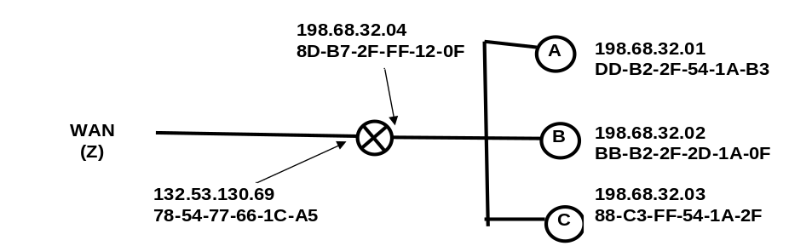
Figure 1: Simple Network with a Router Using the NAT Protocol

NAT Translation Table
WAN side address | LAN side address
132.53.130.69, 4500 | 198.68.32.01, 3340
132.53.130.69, 3250 | 198.68.32.02, 4505
132.53.130.69, 2200 | 198.68.32.02, 4500
… | …
Fill in the source and destination IP addresses and port numbers that will be carried in datagrams at the following four points in the network.
(8 points)

 | Outgoing |  |  | Incoming
 | From B to router | From router to Z | From Z to router |  | From router to B
Source IP
Source Port
Dest. IP
Dest. Port
- TCP congestion control uses the number of duplicate acks and timeouts to determine the transmission rate. Assume the following events:

- Transmission of data begins at time 0 (RTT 0) with a congestion window size equal to 1 MSS (Maximum Segment Size).
- Three duplicates acks are received between RTT 4 and RTT 5.
- A timeout event occurs between RTT 6 and RTT 7.
- Positive acks received during all other RTT intervals

Write the size of the congestion window and the threshold for each RTT period in terms of MSS. The CongWin should be adjusted at the end of each RTT interval based on what happens in the interval. (8 points)

Time | Size of congestion Window (CongWin) in Maximum Segment Sizes (MSS) | Threshold in MSS
0 RTT | 1 | ∞
1 RTT
2 RTT
3 RTT
4 RTT
5 RTT
6 RTT
7 RTT
8 RTT
- Below is a portion of a routing table.

Prefix | Link Interface
11001111 00010011 1001 | 0
11001111 00010011 10011001 | 1
11001011 00010111 00011 | 2
Otherwise | 3

    - Give the Classless InterDomain Routing (CIDR) notation for the subnets identified by the first two rows of the table (for example 200.23.16.0/23). Indicate approximately how many hosts each sub-net could contain.
(8 points)

CIDR notation Approx. Number of Hosts

________________________ __________

________________________ __________

    - Using the destination IP addresses, determine which link interface each of the following packets should be sent to. (6 points)

Destination IP Address | Link Interface
11001111 00010011 10011001 11011101
11001111 00010011 10010011 00011000
11001011 00010101 00011000 10101101

- List which transport layer protocols perform flow control. Use no more than two sentences to describe the purpose of flow control? (4 points)

- Using node E in Figure 1 as the source, use the link state (LV) algorithm to find the shortest path to all other nodes. Show the members of N, the predecessor of each destination, and the shortest known distance to each destination after the initialization phase of the algorithm and after each iteration of the main loop. (12 points)
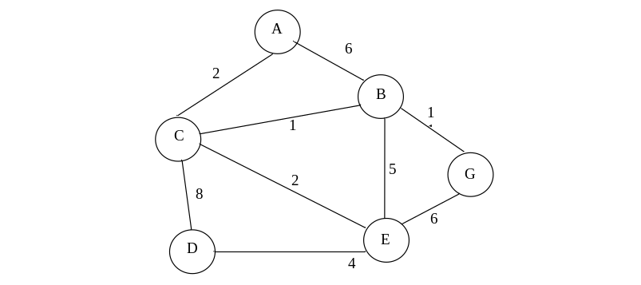
Figure 2: Network Graph

- Write down the shortest path to all destinations in Figure 1 using the predecessor data in the table you created in the previous question. In other words drawn the minimum spanning tree (MST). (4 points)

- How does the TCP protocol detect duplicate packets? Does UDP use this mechanism? (3 points)

- How does the TCP protocol detect lost packets? Does UDP use this mechanism? (3 points)

- How does the TCP protocol detect corrupt packets? Does UDP use this mechanism? (3 points)

- List the two primary manifestations of network congestion that can be observed by a “sender” using TCP. Describe what will occur if no attempt to control the congestion is made (no more than two sentences).

_______________________ ________________________

- Explain why the last calculated RTT (sampleRTT) is not used as the TimeoutInterval (no more than three sentences).

- If some fragments of a datagram are corrupted, what will the IP protocol do with uncorrupted fragments that are received? (3 points)

